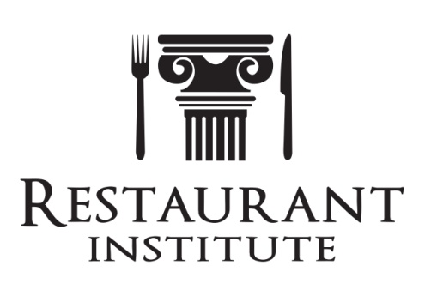
Contact: Mark Kelnhofer
614.558.2239
Mark@RestaurantInstitute.com
P.O. Box 2387, Westerville, OH 43082

For immediate release
September 2, 2016

THIRD EDITION OF THE CULINARY POCKET RESOURCE
OF YIELDS, WEIGHTS, DENSITIES, & MEASURES RELEASED
Westerville, OH – Restaurant Institute today released on Amazon the third edition of The Culinary Pocket Resource of Yields, Weights, Densities, & Measures by Mark Kelnhofer, President & CEO of Return On Ingredients® and international speaker on cost controls. Topics are process yields, can yields, food sizes and grading, labor time conversions, densities, and much more.
“This edition has data that all restaurant and foodservice operators should have when determining proper recipe costs and enhancing their menu engineering. There is nothing like this that provides such a large impact to the business” stated Kelnhofer.
Kelnhofer is a well known speaker on recipe costing, menu engineering, and cost controls. He has spoken at dozens of industry related tradeshows and seminars, including Restaurant Institute’s Food & Beverage Cost Management Summits which will be conducted in Las Vegas, San Diego, Dallas, and Orlando this year. Kelnhofer is a Lecturer at The Ohio State University, instructing Food, Beverage, and Labor Cost Controls and sits on several hospitality advisory boards. The pocket resource is also integrated into the Restaurant Institute mobile app, allowing food professionals easy access to the publication on their phones or devices and is available on Google Play and Android stores.
# # #

