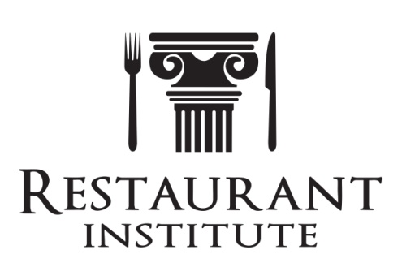
Contact: Mark Kelnhofer
614.558.2239
Mark@RestaurantInstitute.com
P.O. Box 2387, Westerville, OH 43082

PRESS RELEASE – January 18, 2017

2017 F&B COST MANAGEMENT SUMMITS TO HELP
RESTAURANT & FOODSERVICE OPERATOR PROFITABILITY
Westerville, OH -- Restaurant and foodservice operators will learn proven profit-building strategies in a one day Food & Beverage Cost Management Summits in 2017. The Summits are presented by Mark Kelnhofer, a widely recognized expert, international speaker and published author on the subjects. Topics covered are accurate recipe costing, menu engineering, purchasing specifications, forecasting methods, vetting cost control systems and much more.
The 2017 events are in 14 cities nationally kicking off in April in Columbus, OH (04/17) at the Greater Columbus Convention Center. Other cities that follow are Louisville, KY (06/05), Buffalo (06/12), Indianapolis (06/19), Atlanta (07/16), Seattle (07/23), Boston (07/30), Milwaukee (08/06), Phoenix (08/13), Detroit (08/21), Washington, DC (08/27), Pittsburgh (09/04), Houston (09/24), and closes out in Las Vegas (10/15). More information and details can be obtained from the Restaurant Institute website (www. RestaurantInstitute.com/Events/).
Kelnhofer is President and CEO of Return On Ingredients® in Westerville, Ohio and is a speaker bureau member for Restaurant Institute. He has been a featured speaker at nearly a hundred national and regional foodservice, hospitality, and financial conventions nationwide. He has been published in various industry publications including Entrepreneurial Chef, QSR, FSR, Las

2017 COST MANAGEMENT SUMMITS TO HELP RESTAURANT & FOODSERVICE OPERATOR PROFITABILITY - 2
-more-
Vegas Food & Beverage Professional, Catering, Foodservice Equipment & Suppliers, Sunbelt Foodservice, Today’s Restaurant News, and UrnerBarry’s The Reporter.
He also has published two books, Return On Ingredients: Controlling Food & Beverage Costs To Improve Efficiencies & Profits and The Culinary Pocket Resource of Yields, Weights, Densities & Measures.
Recipe documentation accuracy is essential for every operator because it affects many aspects of the operation. Without properly documented recipes, operators can’t properly manage their business to greater profitability.
Participants learn: the art of recipe writing; proper costing; how to understand basic financial statements and methods of analysis; menu engineering techniques; forecasting methods; how to implement just-in-time practices; establishing and maintaining pars; andperformance benchmarking. Attendees will also learn how to evaluate and select the best cost control system.
Kelnhofer is a Lecturer at The Ohio State University instructing Food, Beverage, and Labor Cost Control and also an Adjunct Faculty member at Ohio University instructing Hospitality Accounting. He also sits on several hospitality advisory boards including Ohio University (Athens, OH) and Hocking College (Nelsonville, OH).
###

